**Azure devops Banking Application**

**Devops-boards:**

**Step1**: Log in Azure devops and create a new project named Banking app.

**Step-2:**breakdown the application parts into epics,features,user stories and tasks.

The following screenshots are board development of the Banking application:

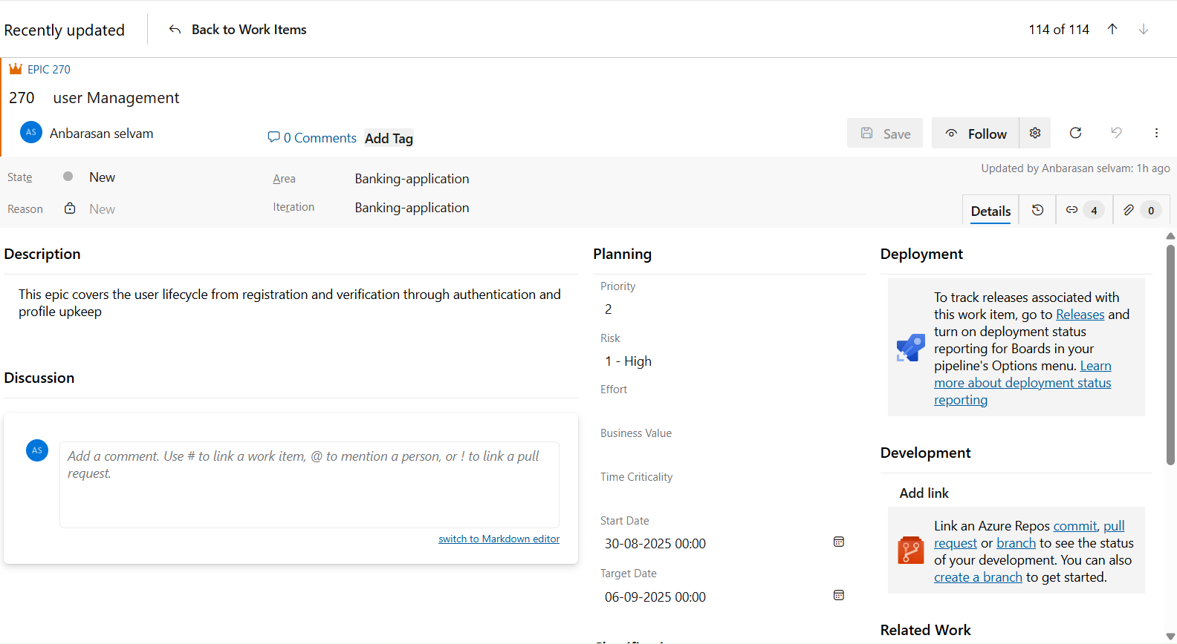

The feature:

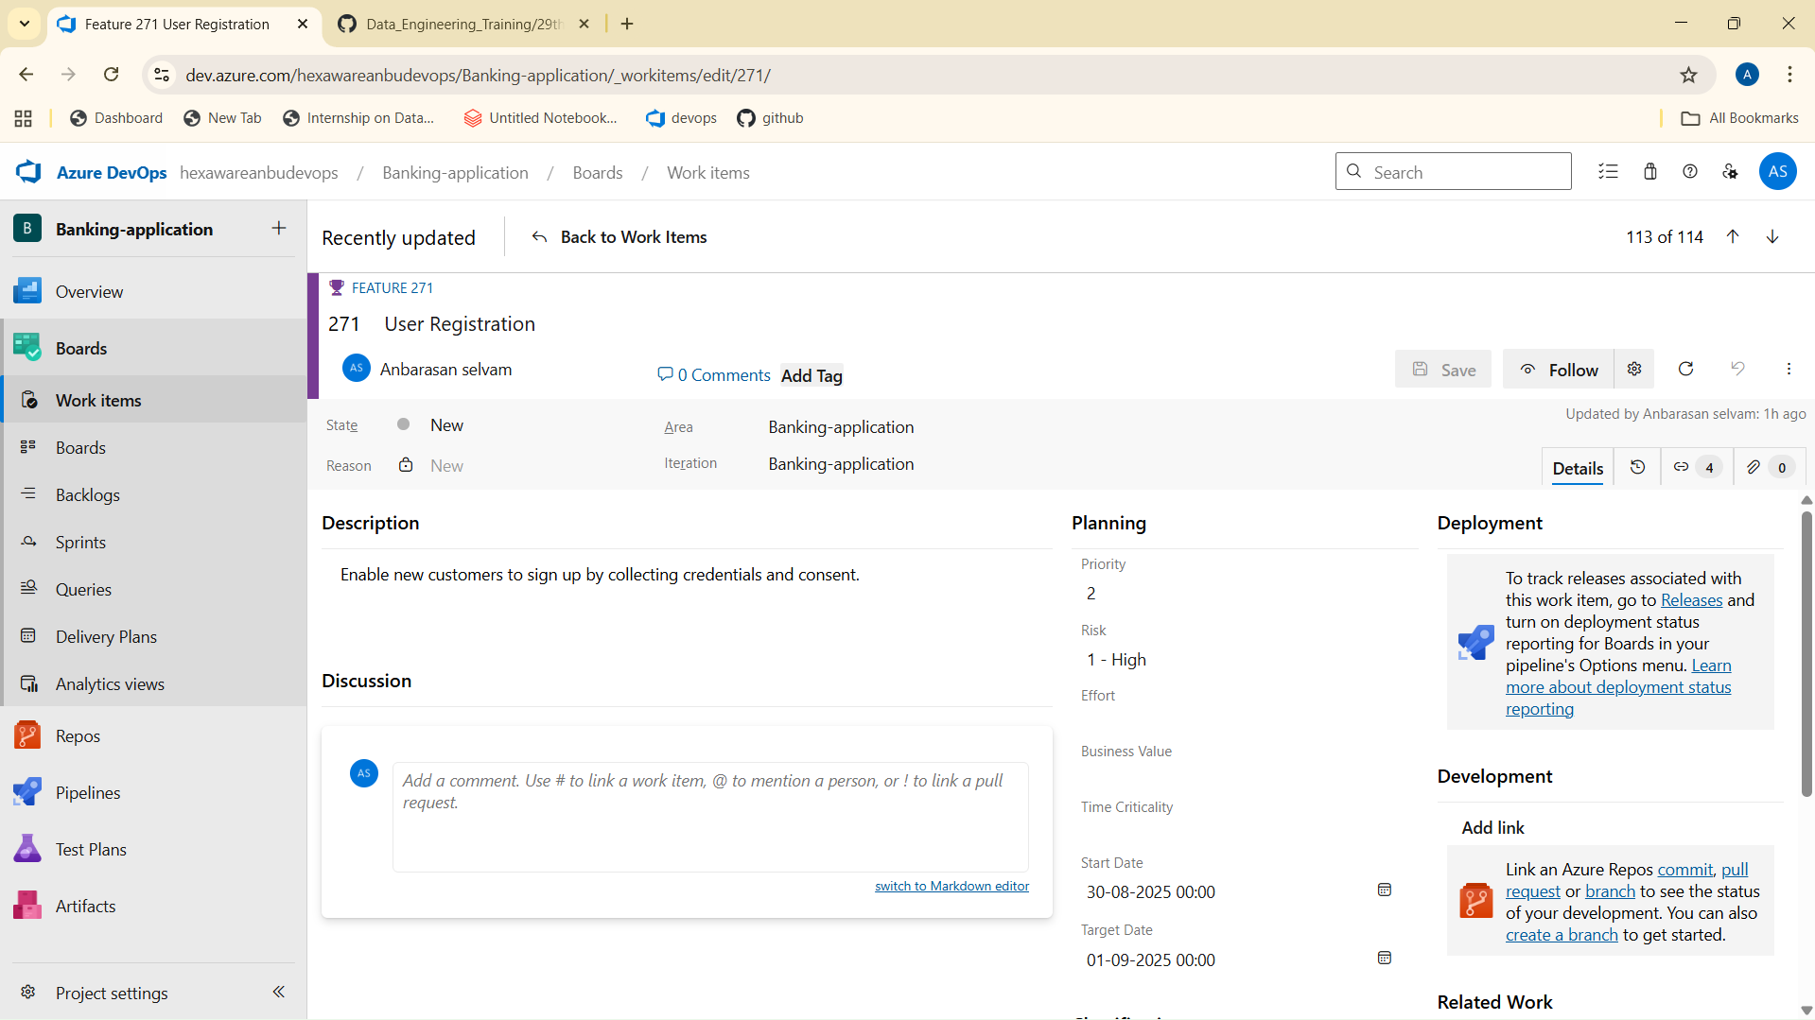

The user story:

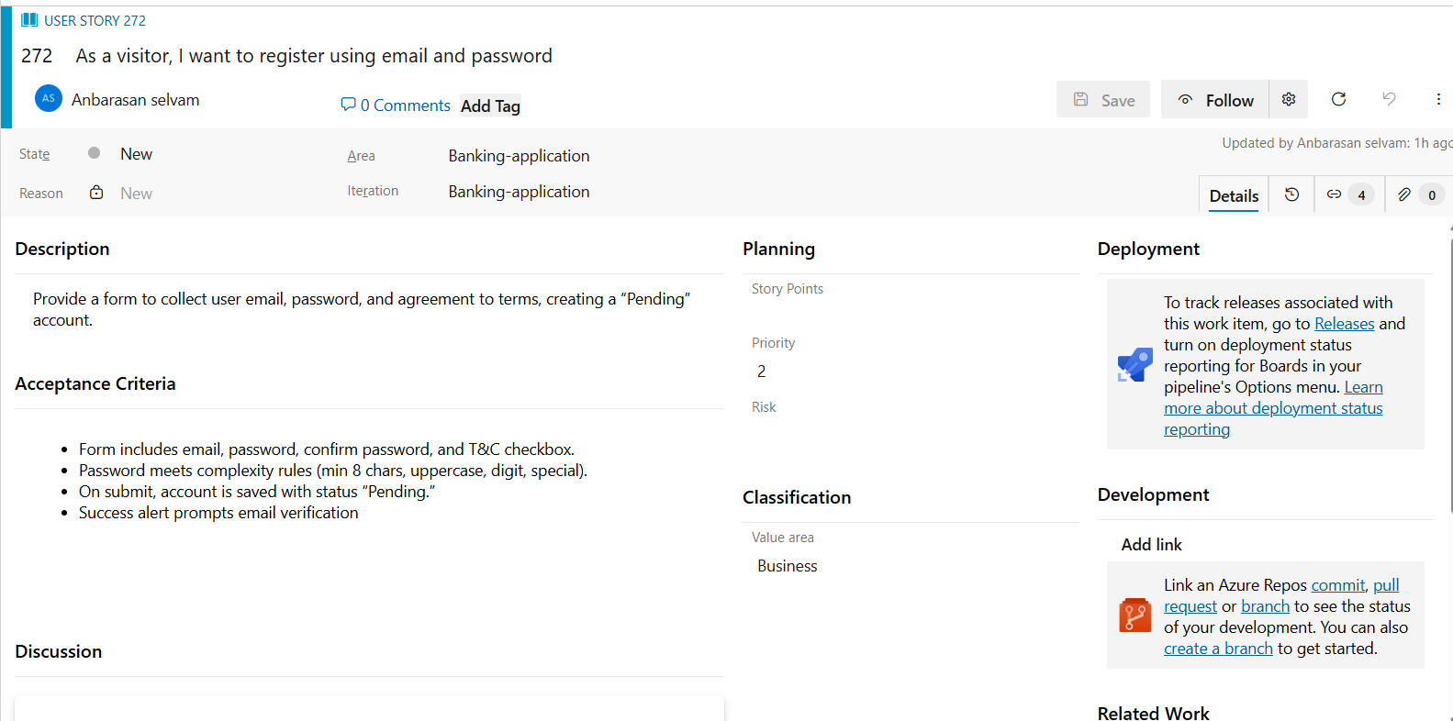

The task**:**

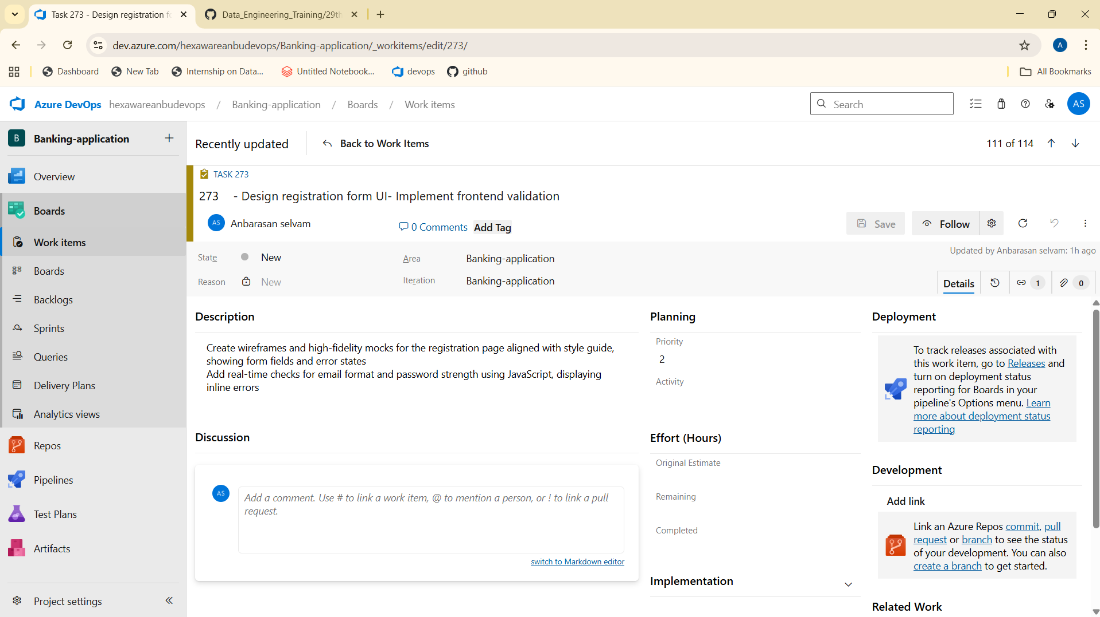

**Sample Structure of an epic:**

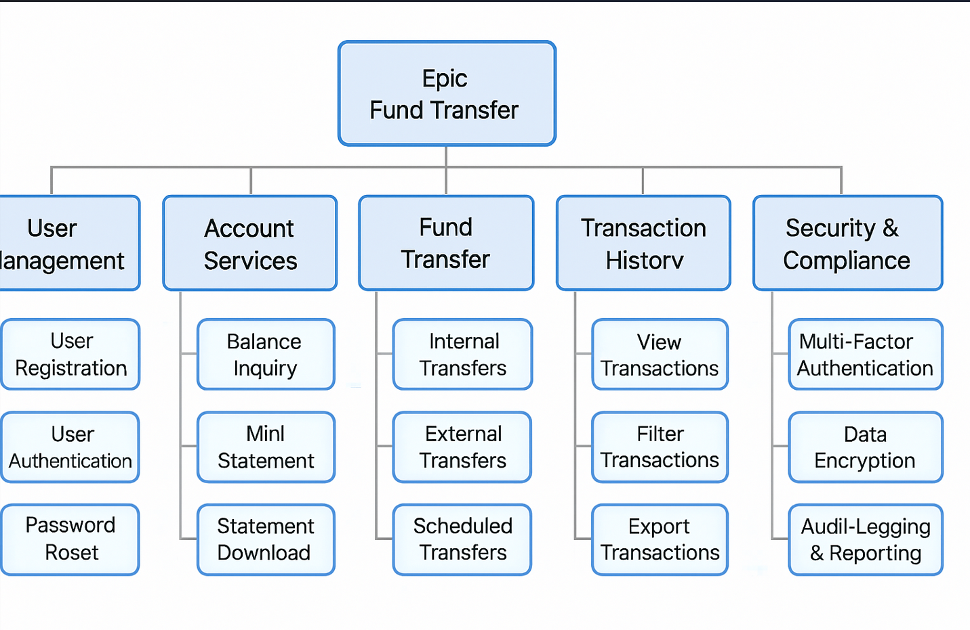

**For the entire application :**

* 5 epics
* 3 +features each
* 3 user stories each
* 5 tasks each build

Overall flow sample screenshots :

